**apalm1341-**Today at 12:47 PM

hey all

I am trying to compile and run two of my java programs

and am getting this

**crueltyinc-**Today at 12:49 PM

what's "this"?

**apalm1341-**Today at 12:49 PM

well

I can't past in pics in here

can I?

it not letting me for some weird reason

**KubeRoot-**Today at 12:49 PM

Just upload it somewhere and post a link

**crueltyinc-**Today at 12:49 PM

imgur

**KubeRoot-**Today at 12:50 PM

The admins disabled it on this server for some reason

**apalm1341-**Today at 12:52 PM

<http://imgur.com/a/CKbU7>

[Imgur](https://imgur.com/)

[**Imgur: The most awesome images on the Internet**](http://imgur.com/a/CKbU7)

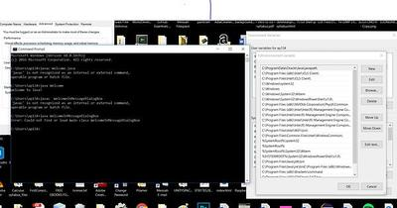

does this work for you guys?

can you see it?

**crueltyinc-**Today at 12:53 PM

yep

have you rebooted since you changed your path?

**apalm1341-**Today at 12:55 PM

u mean restart my computer?

**crueltyinc-**Today at 12:55 PM

yeah, or just log off current user and log back on(edited)

**apalm1341-**Today at 12:56 PM

no I haven't done either one yet

should I try one?

which one?

**crueltyinc-**Today at 12:56 PM

yeah, but hang on

**apalm1341-**Today at 12:56 PM

ok

**crueltyinc-**Today at 12:56 PM

2.5'th one from the bottom on the right

missing a ;

**apalm1341-**Today at 12:57 PM

actually

I might not have done either of the things u mentioned yet?

not sure

mybad

C:\Program Files\Java\jre\binC:\Program Files (x86)\Windows Live\Shared

here??

**crueltyinc-**Today at 12:57 PM

yeah

those should be two entries

**apalm1341-**Today at 12:57 PM

where should I put semicolon?

how do I make it two entries?

**crueltyinc-**Today at 12:58 PM

C:\Program Files\Java\jre\bin;C:\Program Files (x86)\Windows Live\Shared

**apalm1341-**Today at 12:58 PM

oh

**crueltyinc-**Today at 12:58 PM

or delete it

**apalm1341-**Today at 12:58 PM

so semilicon makes it two entries?

two separate ones?

**crueltyinc-**Today at 12:59 PM

and make C:\Program Files\Java\jre\bin and C:\Program Files (x86)\Windows Live\Shared

yeah, that'll muck up any java commands

**apalm1341-**Today at 12:59 PM

muck up?

**crueltyinc-**Today at 1:00 PM

mess up

it's also missing version numbers, if I'm seeing this right

open the folder C:\Program Files\Java

**apalm1341-**Today at 1:01 PM

<http://imgur.com/a/9pwZt>

[Imgur](https://imgur.com/)

[**Imgur: The most awesome images on the Internet**](http://imgur.com/a/9pwZt)

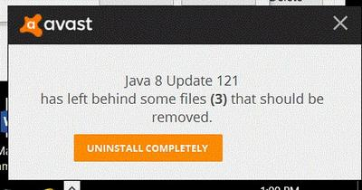

also getting this avast message

**Yaeger-**Today at 1:01 PM

Windows, *triggered*(edited)

**crueltyinc-**Today at 1:01 PM

eh, avast can hush

**apalm1341-**Today at 1:03 PM

wait

should I edit text right now?

and add semicolon?

in this line C:\Program Files\Java\jre\binC:\Program Files (x86)\Windows Live\Shared

what should I do first?

**crueltyinc-**Today at 1:06 PM

hang on, I'll write a todo list... since I made it confusing(edited)

**apalm1341-**Today at 1:06 PM

ok

**crueltyinc-**Today at 1:10 PM

1) Delete the line C:\Program Files\Java\jre\binC:\Program Files (x86)\Windows Live\Shared 2) Add a new line with C:\Program Files (x86)\Windows Live\Shared 3) Go to C:\Program Files\Java 4) Add the line C:\Program Files\Java[JDK] and replace [JDK] with the name of the folder that starts with jdk. 5) Add the line C:\Program Files\Java[JRE] and replace [JRE] with the name of the folder that starts with jre. 6) Restart your computer. 7) Open a command prompt. 8) Run java -version in the command prompt, and you should get your current installed version (the number you saw in step 4). 9) Run javac -version in the command prompt, and you should get your current installed version (the number you saw in step 5).(edited)

**apalm1341-**Today at 1:15 PM

ok

I am on step 5 now

I have two different JRE folders tho

one called "jre"

the other one called "jre1.8.0_121"

within here: C:\Program Files\Java

u still there?

**crueltyinc-**Today at 1:17 PM

huh, that's weird

**apalm1341-**Today at 1:17 PM

ya

**crueltyinc-**Today at 1:17 PM

what's in jre?

**apalm1341-**Today at 1:17 PM

i think itis cause I had to keep uninstalling

and reinstalling/redownloading

**crueltyinc-**Today at 1:18 PM

I'd use jre1.8.0_121, it's the latest version and the jre folder confuses me lol(edited)

**apalm1341-**Today at 1:19 PM

<http://imgur.com/a/ei6xT>

[Imgur](https://imgur.com/)

[**Imgur: The most awesome images on the Internet**](http://imgur.com/a/ei6xT)

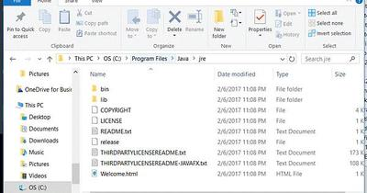

<http://imgur.com/a/eM94p>

[Imgur](https://imgur.com/)

[**Imgur: The most awesome images on the Internet**](http://imgur.com/a/eM94p)

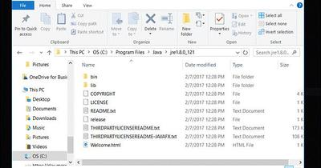

?

still think I should use jre u mentioned above?

**crueltyinc-**Today at 1:21 PM

Open the release file with a text editor

**apalm1341-**Today at 1:21 PM

which one?

**crueltyinc-**Today at 1:21 PM

the one in the jre folder(edited)

**apalm1341-**Today at 1:21 PM

ok

JAVA_VERSION="1.8.0_121" OS_NAME="Windows" OS_VERSION="5.2" OS_ARCH="amd64" SOURCE=" .:f2b5b6ab1f55 corba:386e9b79fcf5 deploy:7130ca3292fd hotspot:90f94521c351 hotspot/make/closed:bb6215e98e28 hotspot/src/closed:5c67a72be91c hotspot/test/closed:262c6cd71fd1 install:709a5016570e jaxp:b8d4e4724071 jaxws:5b8834cc3bb9 jdk:2974746e5619 jdk/make/closed:14736f778a50 jdk/src/closed:784a1cdcf90e jdk/test/closed:75844215d99a langtools:f634736433d9 nashorn:fd548ea7e156 pubs:6c3449393359 sponsors:d32775ed283a" BUILD_TYPE="commercial"

that shows up in notepad

**crueltyinc-**Today at 1:22 PM

hah, they're both the same then

which is weird

**apalm1341-**Today at 1:22 PM

oh ok

should I delete one folder?

**crueltyinc-**Today at 1:23 PM

but it works

**apalm1341-**Today at 1:23 PM

or keep both?

**crueltyinc-**Today at 1:23 PM

actually, what's in the same file under jre1.8.0_121?

out of curiosity

**apalm1341-**Today at 1:25 PM

JAVA_VERSION="1.8.0_121" OS_NAME="Windows" OS_VERSION="5.2" OS_ARCH="amd64" SOURCE=" .:f2b5b6ab1f55 corba:386e9b79fcf5 deploy:7130ca3292fd hotspot:90f94521c351 hotspot/make/closed:bb6215e98e28 hotspot/src/closed:5c67a72be91c hotspot/test/closed:262c6cd71fd1 install:709a5016570e jaxp:b8d4e4724071 jaxws:5b8834cc3bb9 jdk:2974746e5619 jdk/make/closed:14736f778a50 jdk/src/closed:784a1cdcf90e jdk/test/closed:75844215d99a langtools:f634736433d9 nashorn:fd548ea7e156 pubs:6c3449393359 sponsors:d32775ed283a" BUILD_TYPE="commercial"

**crueltyinc-**Today at 1:25 PM

yep, exact same thing

**apalm1341-**Today at 1:25 PM

ok

**crueltyinc-**Today at 1:25 PM

You can use either/or. I'd keep both, because I'm paranoid.

**apalm1341-**Today at 1:26 PM

ok

I will keep both jre folders then

**crueltyinc-**Today at 1:26 PM

but I need to make a correction

**apalm1341-**Today at 1:26 PM

u r talking about keeping both jre folders right?

**crueltyinc-**Today at 1:26 PM

ye

**apalm1341-**Today at 1:26 PM

ok

**crueltyinc-**Today at 1:26 PM

1) Delete the line C:\Program Files\Java\jre\binC:\Program Files (x86)\Windows Live\Shared 2) Add a new line with C:\Program Files (x86)\Windows Live\Shared 3) Go to C:\Program Files\Java 4) Add the line C:\Program Files\Java\[JDK]\bin and replace [JDK] with the name of the folder that starts with jdk. 5) Add the line C:\Program Files\Java\[JRE]\bin and replace [JRE] with the name of the folder that starts with jre. 6) Restart your computer. 7) Open a command prompt. 8) Run java -version in the command prompt, and you should get your current installed version (the number you saw in step 4). 9) Run javac -version in the command prompt, and you should get your current installed version (the number you saw in step 5).(edited)

Notice changes in steps 4 & 5

**apalm1341-**Today at 1:29 PM

so what should I put in place of [JRE]?

jre1.8.0_121

or jre?

not matter?

**crueltyinc-**Today at 1:30 PM

doesn't matter

**apalm1341-**Today at 1:30 PM

ok cool

<http://imgur.com/a/BVY9A>

[Imgur](https://imgur.com/)

[**Imgur: The most awesome images on the Internet**](http://imgur.com/a/BVY9A)

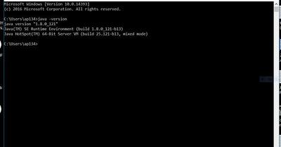

ok

I believe I restarted my computer and then this happened

**crueltyinc-**Today at 1:40 PM

**apalm1341-**Today at 4:15 PM

u mean in order to go to the folder where files r in, u gotta tap w?

w key on keyboard?

oh

wait a sec

maybe cause I am trying to find the files after clicking save as

within my notepad editor

maybe I gotta find it by clicking on desktop file explorer icon instead?

**crueltyinc-**Today at 4:17 PM

wait, where are you looking for the file in? Explorer or Notepad?

**apalm1341-**Today at 4:17 PM

notepad

that is what I just said/meant

now I am trying file explorer desktop app

[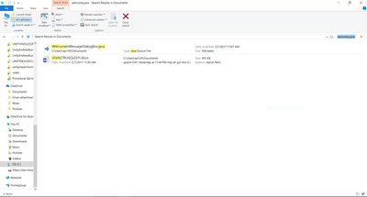](https://cdn.discordapp.com/attachments/227521002056187904/278635559977484290/unknown.png)

uh..........

why is only the one file in here?

and not the other one?

there should be Welcome.java in there too I thought??

cause I searched Welcome.java

**crueltyinc-**Today at 4:19 PM

Did you save it in there?

**apalm1341-**Today at 4:19 PM

in file explorer

**crueltyinc-**Today at 4:19 PM

Not in your downloads or something?

or desktop?

**apalm1341-**Today at 4:20 PM

how can I find where my files located at?

after clicking save as

?

in notepad?

**crueltyinc-**Today at 4:21 PM

ye

So if you have Welcome.java open still...

**apalm1341-**Today at 4:21 PM

is that how it is for all application for desktops?

**crueltyinc-**Today at 4:21 PM

just click save as and see where it's pointed to

It should be a standard thing, ye.

**apalm1341-**Today at 4:22 PM

[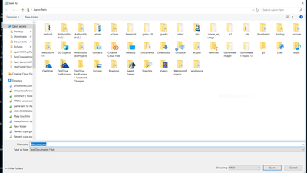](https://cdn.discordapp.com/attachments/227521002056187904/278636583496843265/unknown.png)

alright

this is what it looks like after clicking save as

after being in Welcome.java file in notepad

**crueltyinc-**Today at 4:23 PM

open the Document folder and save it there

**apalm1341-**Today at 4:23 PM

C:\Users\ap134\Documents

here?

**crueltyinc-**Today at 4:23 PM

ye

since that's where you have the other one at the moment

**apalm1341-**Today at 4:23 PM

ok

does it matter what encoding is listed?

**crueltyinc-**Today at 4:24 PM

nah

**apalm1341-**Today at 4:24 PM

does that ever metter?

**crueltyinc-**Today at 4:24 PM

I ignore it

**apalm1341-**Today at 4:24 PM

matter

not metter

**crueltyinc-**Today at 4:24 PM

But I don't use Notepad anymore, either, so I forgot it was a thing.

**apalm1341-**Today at 4:24 PM

ok

**crueltyinc-**Today at 4:25 PM

after you save, before you compile, make a folder on your desktop, name it Java, and move your two .java files into it

**apalm1341-**Today at 4:25 PM

ok

I have so much crap on my desktop right now

what is easiest way to fix that?

so I don't have a bunch of crap all over the place?

**crueltyinc-**Today at 4:27 PM

Move it into other folders, if possible.

**apalm1341-**Today at 6:00 PM

hey again

u there?

**NEW MESSAGES**

**crueltyinc-**Today at 6:06 PM

yep

**apalm1341-**Today at 1:01 PM

hey

**crueltyinc-**Today at 1:01 PM

hello

**apalm1341-**Today at 1:02 PM

u mind using teamviewer and/or screenhero?

**crueltyinc-**Today at 1:02 PM

at work atm, so unfortunately not an option

**apalm1341-**Today at 1:02 PM

ok

**crueltyinc-**Today at 1:03 PM

I can this evening (in 9/10 hours) if it works for you as well

**apalm1341-**Today at 1:04 PM

ok

possibly

not sure

I sent some more messages in group chat place

**crueltyinc-**Today at 1:04 PM

haha ok

**apalm1341-**Today at 6:03 PM

hey again

thx for all your help

really appreciated it earlier

**crueltyinc-**Today at 6:06 PM

no prob! I appreciate the exercise(edited)

**apalm1341-**Today at 6:06 PM

C:\Users\ap134>javac WelcomeInMessageDialogBox.java javac: file not found: WelcomeInMessageDialogBox.java Usage: javac <options> <source files> use -help for a list of possible options

however

my one file isn't working

and it looks like I have it in the correct location

**crueltyinc-**Today at 6:07 PM

is the WelcomeInMessageDialogBox.java file in the folder C:\Users\ap134?

**apalm1341-**Today at 6:07 PM

C:\Users\ap134\Desktop\Javaprograms!>javac WelcomeInMessageDialogBox.java WelcomeInMessageDialogBox.java:3: error: class, interface, or enum expected */ in a message dialog box! ^ 1 error

this is right now

**crueltyinc-**Today at 6:07 PM

ah k

**apalm1341-**Today at 6:08 PM

ignore the first thing I sent u

srry

**crueltyinc-**Today at 6:08 PM

no prob

I'm guessing that you're having problems with comments here

*/ ends a block comment, but the remainder of the line should probably be part of the comment.

**apalm1341-**Today at 6:08 PM

[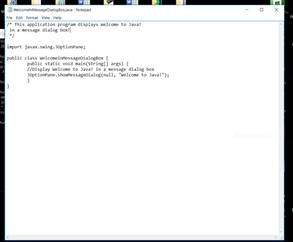](https://cdn.discordapp.com/attachments/278586109477388299/278663332146446336/unknown.png)

looks like this for me now

**crueltyinc-**Today at 6:09 PM

Is it saved?

**apalm1341-**Today at 6:09 PM

I thought I did this right cause multiline/block comments start with /* and end with */

yes

I saved it multiple times

**crueltyinc-**Today at 6:09 PM

and it's giving you that error still?

**apalm1341-**Today at 6:10 PM

yep

I just saved it and ran it again

same error

**crueltyinc-**Today at 6:10 PM

When you save as, is it still pointing to your ap134 folder?

**apalm1341-**Today at 6:10 PM

I made sure to change the directory to where my code file is too

cd then file path

in my command prompt im talking about

no

it isn't

odd

oh

maybe I am in wrong file

maybe I made another file

hold up

**crueltyinc-**Today at 6:12 PM

mmk

**apalm1341-**Today at 6:13 PM

C:\Users\ap134\Desktop\Javaprograms!>javac WelcomeInMessageDialogBox.java WelcomeInMessageDialogBox.java:3: error: class, interface, or enum expected */ in a message dialog box! ^ 1 error C:\Users\ap134\Desktop\Javaprograms!>java WelcomeInMessageDialogBox Error: Could not find or load main class WelcomeInMessageDialogBox

still getting same thing

[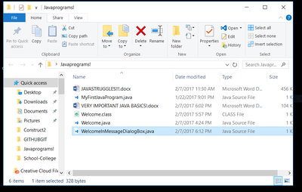](https://cdn.discordapp.com/attachments/278586109477388299/278664678056394753/unknown.png)

I am in right locating in notepad now

with code file

I was just in the same file in another location looking at it in notepad

**crueltyinc-**Today at 6:15 PM

do you have chrome on your computer?

**apalm1341-**Today at 6:15 PM

chrome browser app?

**crueltyinc-**Today at 6:15 PM

yeah

**apalm1341-**Today at 6:15 PM

yes

why?

**crueltyinc-**Today at 6:15 PM

<https://chrome.google.com/webstore/detail/chrome-remote-desktop/gbchcmhmhahfdphkhkmpfmihenigjmpp?utm_source=chrome-ntp-icon>

[**Chrome Remote Desktop**](https://chrome.google.com/webstore/detail/chrome-remote-desktop/gbchcmhmhahfdphkhkmpfmihenigjmpp?utm_source=chrome-ntp-icon)

Access other computers or allow another user to access your computer securely over the Internet.

install that real quick

I can do that one at work

**apalm1341-**Today at 6:17 PM

u have screenhero and/or teamviewer?

**crueltyinc-**Today at 6:17 PM

nope

that's the one i can use

**apalm1341-**Today at 6:17 PM

ok

?

**crueltyinc-**Today at 6:18 PM

?

**apalm1341-**Today at 6:18 PM

why is it redirecting me to chrome browser app it looks like?

[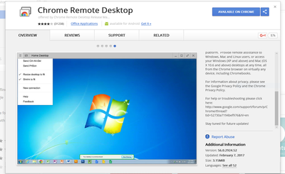](https://cdn.discordapp.com/attachments/278586109477388299/278665882820149248/unknown.png)

**crueltyinc-**Today at 6:18 PM

That's what I linked you, yes

**apalm1341-**Today at 6:19 PM

after clicking on available on chrome this below shows up

**crueltyinc-**Today at 6:19 PM

It's a Chrome extension.

**apalm1341-**Today at 6:19 PM

[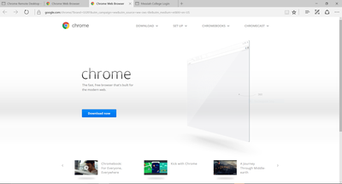](https://cdn.discordapp.com/attachments/278586109477388299/278666053720997888/unknown.png)

**crueltyinc-**Today at 6:19 PM

It also has an application that needs to be installed. Both are made by Google. Both are secure.

**apalm1341-**Today at 6:19 PM

click download now here?

**crueltyinc-**Today at 6:19 PM

I am a random person on the internet though, so feel free to reject if you feel uncomfortable.

Yes.

**apalm1341-**Today at 6:22 PM

?

uh

I downloaded and installed it I think

now what?

I don't see anything else

**crueltyinc-**Today at 6:22 PM

Open your Chrome, go to chrome://apps, and open the Chrome Remote Desktop app.

Then Click the green Share button, and tell me the code

**apalm1341-**Today at 6:23 PM

oh

ok

I don't see a chrome remote desktop app

it must not have been downloaded/installed?

**crueltyinc-**Today at 6:24 PM

What do you see at chrome://apps?

**apalm1341-**Today at 6:24 PM

[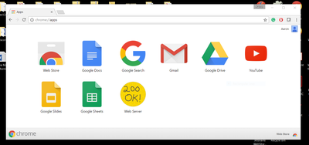](https://cdn.discordapp.com/attachments/278586109477388299/278667374096547850/unknown.png)

that

**crueltyinc-**Today at 6:24 PM

weird

**apalm1341-**Today at 6:24 PM

I think u sent me wrong link or something

not sure

I think what u sent was just for getting chrome desktop browser app

maybe I am wrong tho

**crueltyinc-**Today at 6:25 PM

<https://chrome.google.com/webstore/detail/chrome-remote-desktop/gbchcmhmhahfdphkhkmpfmihenigjmpp> is the one it gives me

[**Chrome Remote Desktop**](https://chrome.google.com/webstore/detail/chrome-remote-desktop/gbchcmhmhahfdphkhkmpfmihenigjmpp)

Access other computers or allow another user to access your computer securely over the Internet.

and it gave you the right page when you installed it

**apalm1341-**Today at 6:25 PM

<https://chrome.google.com/webstore/detail/chrome-remote-desktop/gbchcmhmhahfdphkhkmpfmihenigjmpp?hl=en>

[**Chrome Remote Desktop**](https://chrome.google.com/webstore/detail/chrome-remote-desktop/gbchcmhmhahfdphkhkmpfmihenigjmpp?hl=en)

Access other computers or allow another user to access your computer securely over the Internet.

**crueltyinc-**Today at 6:25 PM

to download the local one

**apalm1341-**Today at 6:25 PM

I think this is right one for me

cause it says add to chrome at top

your link didn't say add to chrome

**crueltyinc-**Today at 6:26 PM

really? weird!

**apalm1341-**Today at 6:26 PM

alright

I got the app now

I gotta eat first real quick tho

can u give me like 5 to ten mins

?

**crueltyinc-**Today at 6:26 PM

yeah no prob

**apalm1341-**Today at 6:26 PM

ok thx

bye

**crueltyinc-**Today at 6:26 PM

bye

**apalm1341-**Today at 6:32 PM

hey

I am back

am multitasking lol

**crueltyinc-**Today at 6:33 PM

haha same

working, listening to the US refugee ban lawsuit, and helping ^^

**apalm1341-**Today at 6:35 PM

u want me to click share?

or access?

for remote assistance?

**crueltyinc-**Today at 6:35 PM

yes

share

you should get a code, which I'll use to connect

**apalm1341-**Today at 6:37 PM

103559122709

hey

**crueltyinc-**Today at 6:38 PM

greetings

**apalm1341-**Today at 6:38 PM

I assume u see and can control my computer now

**crueltyinc-**Today at 6:38 PM

yep

bam

**apalm1341-**Today at 6:39 PM

oh my

sweet

I guess that file must be within this location then since it compiles and runs?

C:\Users\ap134\Desktop\Javaprograms!>

?

**crueltyinc-**Today at 6:40 PM

yep

head in there

**apalm1341-**Today at 6:40 PM

ok cool

**crueltyinc-**Today at 6:40 PM

there'll be a new file

.class

**apalm1341-**Today at 6:41 PM

I didn't realize the comment was screwed up in this file

I thought I changed it

wow

thx

ok

**crueltyinc-**Today at 6:41 PM

no prob ^^

**apalm1341-**Today at 6:42 PM

what is up with the new file class?

I thought I only would have needed a .java file for every program I write in order to run and compile them

?

guess not?

u there?

**crueltyinc-**Today at 6:44 PM

yes

so what happens...

You write your .java file, run javac on it, and a .class file is compiled.

The .class file is the one that gets run by the Java Virtual Machine.

Which is what happens when you run the java command.

**apalm1341-**Today at 6:47 PM

ah

**crueltyinc-**Today at 6:47 PM

It looks for a .class file by that name, and runs it.

**apalm1341-**Today at 6:47 PM

so java c = java command?

**crueltyinc-**Today at 6:47 PM

javac = java compile

**apalm1341-**Today at 6:47 PM

oh

Which is what happens when you run the java command.

u said that

i think u meant to say javac command??

**crueltyinc-**Today at 6:48 PM

1) Write .java file. 2) Run javac on that .java file. 3) .class file is created by javac. 4) Run java on that .class file. 5) Java VM runs the .class file.(edited)

**apalm1341-**Today at 6:54 PM

ah

ok

so u must always create the .class file first

before running the .class file

**crueltyinc-**Today at 6:54 PM

Yes.

**apalm1341-**Today at 6:55 PM

ok

**crueltyinc-**Today at 6:55 PM

When javac wasn't working earlier, you weren't getting that .class file. So, when you tried to java the file, it came back that it wasn't there.

**apalm1341-**Today at 6:58 PM

ah

ok

since javac is what creates the .class file

**crueltyinc-**Today at 6:58 PM

yep

**apalm1341-**Today at 6:58 PM

ok cool

let me try my other program and see if that works

**apalm1341-**Today at 7:00 PM

also, the file we just got to work wasn't working before cause I didn't include part of the comment inside where comment was supposed to go/be??

**crueltyinc-**Today at 7:01 PM

yep

**apalm1341-**Today at 7:01 PM

ok cool

ok looks like my other program/file is working right now too right??

can u still see my screen?

oh nevermind

it ended

u can't

I guess u can't come back in to my computer unless I give you permission (share) again??

C:\Users\ap134\Desktop\Javaprograms!>javac Welcome.java C:\Users\ap134\Desktop\Javaprograms!>java Welcome Welcome to Java!

**crueltyinc-**Today at 7:04 PM

Working!

And yeah, we'd need to have another code generated. Looks like everything's working now though, so no need ^^

**apalm1341-**Today at 7:05 PM

ok cool

how can u tell it is working?

?

**crueltyinc-**Today at 7:05 PM

From what you're saying.

Also, I watched the first one run properly.

**apalm1341-**Today at 7:06 PM

what u mean?

**crueltyinc-**Today at 7:07 PM

When I was connected to your PC, I saw it run.

And the output you just messaged me was what it was supposed to be, right?

**apalm1341-**Today at 7:08 PM

which program u talking about?

I understand from my book now

not sure what u r talking about tho

I apologize

**crueltyinc-**Today at 7:09 PM

It's okay, your stuff is working, that's what I mean.

Also, I'm happy I chose coding and not law. Listening to the case, I couldn't keep my focus like this guy is.(edited)

**apalm1341-**Today at 7:11 PM

lol

yes

I agree

I like coding

hmm

interesting

it looks like I can only compile programs once?

**crueltyinc-**Today at 7:11 PM

"Where's your evidence?" "I said it like 15 minutes ago." All we have to do is declare the variable, and the code never asks us to say it again.

**apalm1341-**Today at 7:11 PM

after I compile once, no need to compile again and can run as many times as I want afterwards?

**crueltyinc-**Today at 7:11 PM

Yes.

You'll want to compile again only if you change the code.(edited)

**apalm1341-**Today at 7:13 PM

ok I assume it will only let me compile again properly if I change the code?

also, what u mean by "Where's your evidence?" "I said it like 15 minutes ago." All we have to do is declare the variable, and the code never asks us to say it again.

?

**crueltyinc-**Today at 7:14 PM

I was comparing law to code.

**apalm1341-**Today at 7:14 PM

oh that didn't have anything to do with what we r talking about?

**crueltyinc-**Today at 7:14 PM

no lol, sorry

**apalm1341-**Today at 7:14 PM

ok

no worries

lol

**crueltyinc-**Today at 7:14 PM

It should let you javac it, but you won't need to if you haven't changed the code.

**apalm1341-**Today at 7:16 PM

well it lets me javac it

but it comes out differently compared to the first time I javac it

I guess that is normal?

running it still comes out the same tho

**crueltyinc-**Today at 7:17 PM

what does it say when you javac it?

**apalm1341-**Today at 7:18 PM

I guess I don't have to worry about it as long I can run the file/program properly??(edited)

**crueltyinc-**Today at 7:18 PM

truth

**apalm1341-**Today at 7:19 PM

C:\Users\ap134\Desktop\Javaprograms!>javac WelcomeInMessageDialog.java javac: file not found: WelcomeInMessageDialog.java Usage: javac <options> <source files> use -help for a list of possible options

says that

**crueltyinc-**Today at 7:19 PM

wrong file

**apalm1341-**Today at 7:20 PM

it still runs properly/fine

weird

**crueltyinc-**Today at 7:20 PM

javac WelcomeInMessageDialogBox.java(edited)

**apalm1341-**Today at 7:20 PM

oh

oh

wow

yep

**crueltyinc-**Today at 7:20 PM

ye

**apalm1341-**Today at 7:21 PM

C:\Users\ap134\Desktop\Javaprograms!>javac WelcomeInMessageDialogBox.java

ok now looks like this

producing nothing afterwards that line

guess that is how it should look?

always?

**crueltyinc-**Today at 7:22 PM

yep

**apalm1341-**Today at 7:22 PM

and in order to compile and/or run you must always click enter first??

?

**crueltyinc-**Today at 7:23 PM

where would you click enter?

**apalm1341-**Today at 7:24 PM

after .java

and/or after class name

I would think

**crueltyinc-**Today at 7:24 PM

oh, when running the javac or java command?

**apalm1341-**Today at 7:24 PM

yes

that is what I mean

**crueltyinc-**Today at 7:25 PM

yes

**apalm1341-**Today at 7:26 PM

ok cool

thx

**crueltyinc-**Today at 7:27 PM

no problem